**mSpray**

Version: 1.1

October 5, 2012

Edmund Seto <seto@berkeley.edu>

**Overview**mSpray is an Android application that tracks indoor residual spraying for malaria control initiatives. It keeps accurate accounting of when and where household sprays occur, who conducted the spraying, the quantities of DDT and pyrethroid pesticides used, and whether spray cans were refilled.

All data are stored on the phones, as well as being transferred over the Internet to a secured server, where the data can be analyzed in real time as sprays occur in the field. The GPS coordinates enable mapping of spray programs.  And, the time stamps of the spray events allow for monitoring of the frequency of spraying in different households.

**Requirements**

Android OS phone, version 2.3.3 and above. Tested on Samsung Galaxy Y phone. Data-enabled phone plan.

**Features**

* Easy to use
* Some minor customizability (e.g., language)
* Time stamp and GPS location of sprays
* IDs of up to 2 spray workers
* Separate tracking of DDT and pyrethroid pesticides.
* All data stored locally on the phone’s memory card.
* Data also stored in real time on Google’s secure servers.
* Stored GPS data are encrypted on the phone.

**Installing mSpray**

1. **First, make sure that “non-market” apps are allowed:**

On the phone, select “Settings” application. Go into “Applications” and place a check mark next to “Unknown Sources – Allow installation of non-Market apps”. A warning message may pop up indicating that “Your phone and personal data are more vulnerable to attack by applications from unknown sources. You agree that you are solely responsible for any damage to your phone or loss of data that may result from using these applications.” Press the “OK” button.

1. **Make sure that the phone is using wireless networks and GPS satellites.**

To do this, in the “Settings” menu go select “Location and Security” and check mark “Use Wireless Networks- Location determined by Wi-Fi and/or mobile networks” and “Use GPS satellites- Locate to street-level (requires more battery plus view of sky)”. Note: options are activated when you see a green check mark so make sure you see a green check mark anytime you want to activate/enable an option.

1. **If you have a previous version of mSpray on the phone, you need to delete the old version from the phone before installing the new version.**
   1. On the phone, select "Settings" application.
   2. In Settings, select "Applications", "Manage applications", mSpray"
   3. Select "Uninstall" and confirm OK.
   4. Afterwards, you should find that mSpray is no longer listed as an application on the phone.
2. **Copy the new version of mSpray (apk file) from your PC to the phone.**
   1. Plug the USB cable into phone and the other end into your computer.
   2. Use finger to “grab” the top of the screen and pull down.  You should see a list of items. (Make sure to drag all the way down to the bottom of the screen or menu will go away.)
   3. Select “USB connected – select to copy files to/from your computer”.
   4. You should now see a green android on your screen. Select “Connect USB Storage”. A warning message titled “Connect USB Storage” will display on screen, click “OK”
   5. You should see a new drive on the PC.
   6. Open the new drive on your PC for the phone, and copy the apk file to the phone. You will now need to “drag” or “copy/paste” the apk file from your PC to the phone drive. The apk file is named: “com.example.mspray.MainActivity.apk”
   7. IMPORTANT. Copy the **contents** of the “Copy_to_SD_Card” folder to the phone’s SD card. (i.e., this means that after the copy, you need to open the “Copy_to_SD_Card” folder and then select “mSprayForm”. Once you have selected “mSprayForm” folder drag or copy/paste this folder into the phone drive .
   8. When you have finished uploading the apk and mSprayForm files on the phone press the “Disconnect USB Storage” on screen. Afterwards, eject the drive, and unplug the cable from phone.
3. **Use the phone’s “file manager” to install mSpray.**
   1. Using the file manager, navigate to the “SD memory card” icon on the phone, and file the apk file. Select the apk file to install the app.
   2. If you don’t have a “file manager” on the phone, you can install one from the Market (or Google Play) app on the phone. Connect to the phone to the internet, and search for “Linda File Manager”, and install it. Then use Linda File Manager to perform step 4a.

**Protocol for use**

There are obviously many different ways in which mSpray can be used for specific malaria control programs. This should serve as a simple guide from which more detailed and program-specific protocols may be developed.

1. **IMPORTANT! Learn how to use the phone.**
   1. Become familiar with the phone by using it for a couple weeks. Every phone has strengths and weaknesses that need to be understood before deploying. Some things to note:
      1. Battery life
      2. Go through all the phones different settings.
      3. User interface (sensitivity, response, how easy/difficult is text entry, screen brightness indoors and outdoors, learn how to use the buttons on the phone – e.g., the power, volume, home, apps, back, and menu buttons)
      4. Network performance
      5. Use the Android Map application to explore the GPS performance.
      6. Phone call clarity (if this is used in your study).
      7. How to reset the phone to bring it back to factory defaults (perhaps a good idea to do before the first deployment, and perhaps in between subsequent deployments).
2. **One time preparation**
   1. mSpray should be preinstalled onto the phones.
   2. Install SIM card into each phone and ensure that network connectivity is available (make a call, try to surf the internet with the phone).
   3. Change settings:
      1. Set the time and date on the phone (For this, press the <Settings> application and scroll down and press the <Date & time> item).
      2. Also in the Settings application, go the <Location> item, and turn on GPS satellites, and turn on Google’s location service (i.e., use both GPS and wifi and mobile networks to get location).
      3. Adjust the delay for when the screen will automatically turn off. In the Settings application, select the “Display” item, and adjust the screen timeout (e.g., to 1 or 2 minutes, which should be sufficient to complete a spray survey form).
      4. Turn on network data (and roaming)

IMPORTANT. Be aware of your cellphone network provider’s pricing for data and roaming.

1. **For each study participant**
   1. Provide each Spray Foreman with training on how to use the phone and mSpray. Have them practice with the phone before going out to actual deployment areas.
   2. Charge each phone entirely, until the red light above the screen, turns to green (takes a few hours).
   3. Clear mSpray data from phones:
      1. Use cable that came with the phone to connect phone to PC.
      2. Use finger to “grab” the top of the screen and pull down.  You should see a list of items.  Select “USB connected – select to copy files to/from your computer”.
      3. When asked, select “Connect USB Storage”, and OK.
      4. You should see a new drive on the PC.
      5. Open the new drive, and delete the “mSpray” folder (Do NOT delete the “mSprayForm” folder) on the SD card.
      6. When you have finished, on the phone press the “Disconnect USB Storage” on screen. Afterwards, eject the drive, and unplug the cable from phone.
   4. On the phone, launch the mSpray program by pressing on its icon from the home screen.

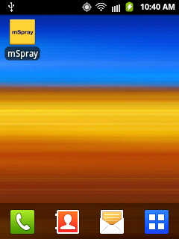 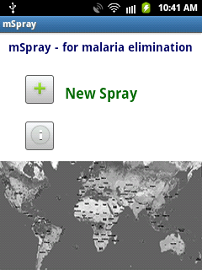

* 1. To start a new spray, foreman should physically go to the household, and stand where there is clear view of the sky so that GPS works. The number of structures in the homestead will determine where GPS reading will be taken. Follow the guidelines below:

If multiple structures on homestead: foreman should take GPS reading closest to the middle of the entry door of the MAIN structure

If there is only one structure: foreman should take GPS reading closest to the middle of the entry door

If there is no clear main structure: foreman should take GPS reading in the center point between all structures. That is locate the center of the area where the structures are and take the reading there.

* 1. Next, press the plus sign next to “New Spray”. This should bring up a spray survey form:

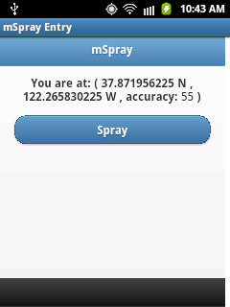

Wait for a GPS coordinate to appear. Also note that the accuracy (shown in meters) of the GPS coordinate may improve if you stand at the location for a longer period of time. The Foreman should allow ~5-30 seconds to lapse so that a more accurate GPS reading is collected. The foreman should NOT move away until the entire form is completed (the “Finish button is pressed in step j below).

* 1. When you are ready to accept the GPS coordinate, press “Spray”.
  2. The next sequence of forms will allow you to enter in the first and second Sprayer IDs. You can press, Next/Back buttons to navigate between the data entry forms.

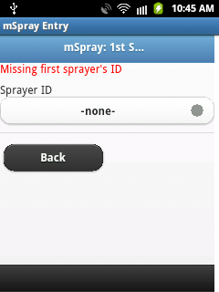 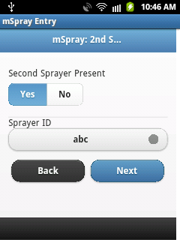

* 1. The next forms will allow you enter data on DDT and K-Orthrine use. Enter whether the pesticide was used. If the pesticide was used, enter the number of rooms sprayed and not sprayed, and whether the spray can was refilled.

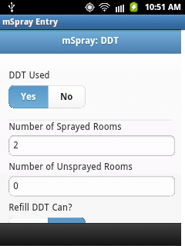 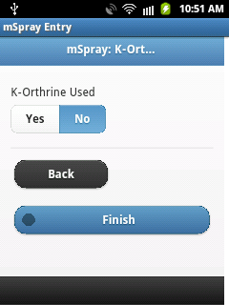

* 1. When the foreman has completed the survey form, press “Finish”. This saves the form to the SD memory on the phone, and submits it to the Internet server.
  2. Recharge the phone after each day of use.
  3. After training, provide foreman with a simple instruction sheet to remind them how to use mSpray while in the field.

1. **To download data**
   1. Use cable that came with phone to connect phone to PC.
   2. On phone, unlock screen by pressing “menu” button.
   3. Use finger to “grab” the top of the screen and pull down.  You should see a list of items.  Select “USB connected – select to copy files to/from your computer”.
   4. When asked, select “Connect USB Storage”
   5. You should see a new drive on the PC.
   6. Open the new drive, and copy the file in the mSpray folder to your PC
   7. To keep organized on your PC, you may want to store data into a separate directory for each spray foreman.
   8. Archive the data, keep it in a safe location, and make a separate copy of these files for data analysis.
   9. Before giving the phone to another foreman, start again at Step 3 above.
2. **To access data over the Internet**
   1. The data is stored on Google’s servers. Contact Dr. Seto <seto@berkeley.edu> on getting password protected access to the data.

**Customization**

To edit the predefined list of Sprayer IDs, you will need to edit the app.html file that resides on the “mSprayForm” folder of the SD card.

Change these lines:

<div data-role="fieldcontain">

<label for="selectmenu1">Sprayer ID</label>

<select name="sprayerID" id="sprayerID" onchange="checkStateSprayer1()">

<option value="-none-">-none-</option>

<option value="abc">abc</option>  
<option value="def">def</option>

</select>

</div>

And also, change these lines:

<div data-role="fieldcontain" id="sprayer2IDInput">

<label for="selectmenu2">Sprayer ID</label>

<select name="sprayer2ID" id="sprayer2ID" onchange="checkStateSprayer2()">

<option value="-none-">-none-</option>

<option value="abc">abc</option>

<option value="def">def</option>

</select>

</div>

For example, if you want to add an sprayer ID “Edmund”, you would change the lines to be:

<option value="Edmund">Edmund</option>

After editing the app.html file, remember to copy the revised file back into the mSprayForm folder of the phone’s SD card.

**Recommended Citation**

Edmund Seto, Daniel Wu, Crystal Dou (2012) mSpray: A malaria control smartphone application for tracking indoor residual spraying. Version 1.1. <http://ehs.sph.berkeley.edu/edmund>

**Questions**

Contact Edmund Seto, PhD

Associate Adjunct Professor, School of Public Health

Associate Faculty Director, CITRIS Health Care Initiative

University of California, Berkeley

Mail: 50 University Hall, Berkeley, CA 94720, U.S.A.

Email: seto@berkeley.edu